606 Water Group newsletter July 2026

In this issue
Rainwater tank rebate programme
Beavers: good deeds and bad
Climate change, water and vegetation
Restoration project—the Punjab (extreme streamkeeping)
Restoration project—the Sahel (mega food forest)
China’s winning ways: a few more things
Langford: trees for air conditioning
Some statistics

Rainwater tank rebate programme If you live in the Juan de Fuca Electoral Area and are not on a water supply system, you may qualify for the JdF Rainwater Tank rebate. Write to the 606 Water Group at 606watergroup@gmail.com or check out details and download an application at our website www.606water.ca You have until August 31 to get your applications in.

Good Beavers Story A Tube station in Ealing, West London, used to flood every time there was a hard rain. City officials wanted to pour heavy cement (really-more hardscape?) and dig more drains. Conservationists proposed moving beavers into the area upstream for a nature-based solution.

In 2023, five wild beavers were moved into a local twenty-acre park called Paradise Fields. The beavers got busy and quickly built dams across a local creek, creating a pond. The water spread out into smaller pathways and the area became a natural sponge that spread and slowed water and released it over time. The Tube station and the neighbourhoods no longer flood. A bonus is that the wetlands have attracted new birds, bats, rare butterflies and freshwater shrimp. Paradise is the only fully public accessible urban beaver site in England. How British beavers help fight flooding from climate change : NPR

Bad Beavers Story Seven of the core members of 606 Water Group attended the recent Sooke / Peninsula Streamkeepers course and it was excellent. That was not the bad story. We heard the bad story from one of the instructors, who said that he was involved in some restoration work which involved naturalizing and supporting some land by a waterway on lower Vancouver Island. A considerable amount of work and money went into planting small trees, but the results were very satisfactory. Later, when they returned to check on the site, they found beavers had chewed down all the new trees. Whoops.

Climate change and the importance of vegetation Much simplified, the Sahel in Africa is a region between a desert and a savannah. Over the millennium, the boundaries shift. About 8000 years ago, what is now the Sahara Desert was a green savannah. There are tipping points, where a rapid change follows a slow progression towards that point. It is not only human activity that influences climate, but in the last two centuries, human activity has been a major influence. In the Sahel, farming, grazing and pollution from industry have all affected the climate and are further changing the boundaries with a loss of fertile land and the southern expansion of the desert. Rapid end of the Green Sahara 8000 years ago

On the Indian subcontinent, early attempts to “modernize” agriculture resulted in increased aridity and decreased crop yields. Industrialization without regard for the environment resulted in dead rivers, dry riverbeds and empty wells. In the Punjab, community driven restoration projects have inspired other restoration projects across the subcontinent and around the planet.

https://www.bbc.com/news/science-environment-32002306 Starting in 1985, India’s Water Man, Rajendra Singh, took up the challenge of a village elder and began re-teaching traditional water management practices such as digging water retaining pits and creating berms and swales. Within a few years, wells nearby refilled and streams started to flow again. With this encouragement, twenty years later, the villagers and farmers had restored seven rivers and their rural economy. Their basic tools were shovels, baskets, and patience.

The Transformation of the River Kali Bein - Prof RR Sant Singh Seechewal is a Sikh monk, who after years of advocating that governments should restore and protect the 160-kilometer Kali Bein River, decided in the year 2000 that the only way to get it done was to do it himself. Again, with little equipment but shovels and baskets, about 3000 volunteers restored the river, and with it, thousands of hectares of farmland were brought back into production. With patience and willpower over a five-year period, the recovery of the river was remarkable. The work included clearing invasive water hyacinth, repairing and replanting riverbanks, and digging settling ponds for village sewage systems. Governments were persuaded to crack down on industrial pollution. The people became guardians of their river. It continues to support a healthy ecosystem that includes new life and health for the people.

Inside Africa's Food Forest Mega-Project In 2007, the United Nations World Food Project began working towards the African Great Green Wall. The project is to restore vegetation and water balance to the Sahel and stop the Sahara Desert from moving south. Success depends on the rain patterns, which are affected by global temperatures and winds, but simply digging holes designed to collect and retain water to allow trees and other vegetation to survive has brought cooler temperatures, better grazing, and increased harvests of wild and domestic foods. It is another project that involves local people and simple tools. The UN personnel provide guidance, but the effort is supported by local governments and willing volunteers. The extent of the African Great Green Wall can be seen in satellite images. When it is completed, it will be about 8000 kilometers long with a minimum width of fifteen kilometres. How the UN is Holding Back the Sahara Desert

A few quick points.
China began a Great Green Wall in 1978, designed to hold back the Gobi and Taklamakan deserts. After a false start, with non-native tree species, the tree planting program is on track to complete with 100 billion trees planted by 2050. China's Great Green Wall | RGS

China is way ahead of the rest of the world when it comes to renewable energy. Centuries old integrated agriculture practices have a “modern” extension. Hectares of vegetative growth under the solar panels are managed in part by grazing sheep and geese, and the panels shelter these food animals, as well as honey bees. Read on…
Inside China’s Massive Agrivoltaic Farms – Millions of Tons of Food Harvested Under Solar Panels

Vegetation growth starts in the cool of the shade There is water even in the desert air. Water vapor condenses to water when the temperature difference triggers precipitation. Grasses and other plants appear under the solar panels in the desert because the cool of the shade is enough to precipitate moisture.

And then there is this Omar Yaghi, who grew up in a refugee community in Jordan, where water was scarce, has developed new molecular structures that capture gasses: carbon dioxide, methane, water vapor…. From this, he went on to build a water harvesting unit that will pull 1000 litres a day from thin air. https://www.theguardian.com/environment/2026/feb/21/nobel-laureate-omar-yaghi-invents-machine-that-harvests-water-from-dry-air

I think that I shall never see an air conditioner as lovely as a tree: Langford Airconditioning is another environmental service provided by trees. In November 2024, Langford Council received the final report for the Urban Forest Management Plan. Urban-Forest-Management-Plan.pdf

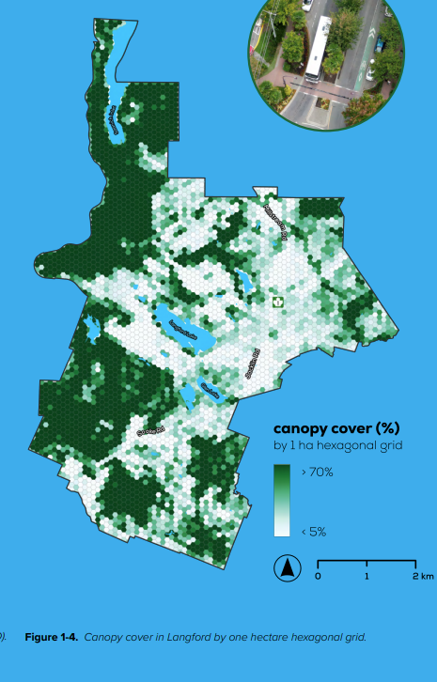
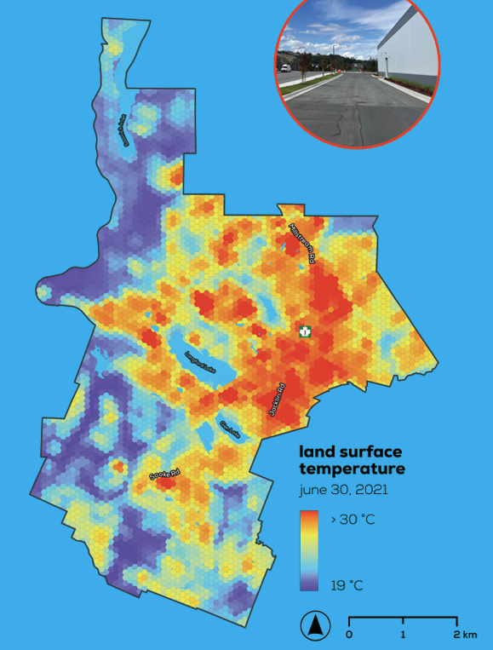

Images are from page/slide 8 of the Urban Forest Management Plan and illustrate the correlation between tree canopy and land surface temperatures on June 30, 2021.
“THREAT FROM EXTREME HEAT The 2021 heat dome revealed a correlation between the risk of death and lower levels of neighbourhood greenness. From June 25 to July 1, temperatures exceeded 30°C, impacting all residents, but in particular older adults and households lacking air conditioning. These conditions contributed to over 600 heat-related deaths in British Columbia during the event. A report by the BC Coroner’s Service both identified low canopy cover as a contributing factor in many of these deaths and advocated for enhancing urban tree canopy in urban areas as part of long-term risk mitigation strategies.”

Some statistics. The beginning of “El Nino” was officially declared on June 11. Extreme weather events were expected, but really?

Manitoba experienced severe flooding in the Parkland Region and both the provincial and federal governments are working to help with recovery efforts. Heavy rainfall in the Assiniboine and Shellmouth River basins was the cause and roads were washed out and buildings flooded.

Kamsack which is located in east-central Saskatchewan at the joining of the Assiniboine and Whitesand Rivers. The sewer system backed up into a significant number of homes.

On July 3, the CBC provided a summary of what has hit Canda so far and offers an explanation of what is happening. What's behind all the wild weather in Canada this summer? | CBC News

Meanwhile, the Sooke Lake reservoir was at 81.9% on July 12, which is 0.7% lower than was reported for July 13, 2025. The Integrated Water Service tracks the average daily use over a five year period. For July, the figure is 212.9 million litres per day. The BC Drought Portal shows East Vancouver Island at Level four drought for the fourth consecutive week. East Vancouver Island includes the Capital Regional District up to Jordan River.

